JAVA網路應用#6

工資103 H34996158 侯瑋明

Q2

import java.net.*;

import java.io.*;

import java.util.Date;

import java.text.DateFormat;

public class TCP_Server extends Object

{

public static void main(String args[])

{

try{

//建立ServerSocket物件, 並向系統要求2013埠

ServerSocket srvSocket = new ServerSocket(2013);

System.out.println("伺服器正常啟動");

Socket socket = srvSocket.accept(); //等待使用者輸入

//--讀取時間日期-------------------------------------------

Date date = new Date();

DateFormat df = DateFormat.getDateTimeInstance(DateFormat.MEDIUM, DateFormat.MEDIUM);

System.out.println("Date: "+ df.format(date));

//----------------------------------------------------------

socket.close();

} catch(IOException e){

System.err.println(e);

}

}

}

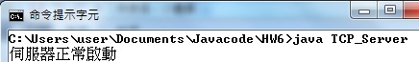

1.2.jpg

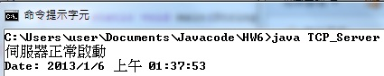

Q3

import java.io.IOException;

import java.net.InetAddress;

import java.net.Socket;

import java.net.*;

public class UDP_Server

{

public static void main(String[] args) throws Exception

{

//設定接收端位址

InetAddress address = InetAddress.getByName("tcf.ncku.edu.tw");

//用迴圈傳送封包檢視接收端回覆情形來看是否in use

for (int port = 1; port <= 65535; port++)

{

try {

byte[] data = new String("Test").getBytes();

DatagramPacket packet = new DatagramPacket(data, data.length,address, 15); //設定UDP封包

DatagramSocket s = new DatagramSocket(port, address);

s.send(packet);

} catch (IOException ex) {

System.out.println("Port " + port + " is in use.");

}

}

}

}

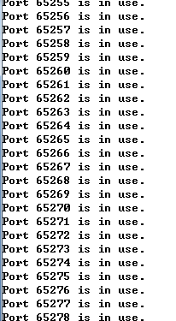

Q5

import java.net.*;

import java.io.*;

public class Server_IP extends Object

{

public static void main(String args[])

{

try{

ServerSocket srvSocket = new ServerSocket(80);

System.out.println("伺服器正常啟動");

while(true){

Socket socket = srvSocket.accept();

Process p = Runtime.getRuntime().exec("cmd.exe /c start " + "http://www.google.com"); //連結80埠下之網址

socket.close();

}

} catch(IOException e){

System.err.println(e);

}

}

}

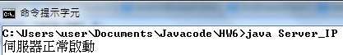

3.2.jpg

